Date: 24/01/2018

Sales Quotation

NIHVA TECHNOLOGIES PVT. LTD.
187, G-Block, Thermax chowk, Above Renault Showroom, MIDC
Chinchwad, Pune – 411019.

Customer Name | DEV TECHNOSKILLS
Project Name | AMAR TEA PLANTATION PVT LTD
Project Location | Mumbai
Contact Person Name | Mr. Devang Parikh
Email Id | Devang@devtechnoskills.co.in
Contact Number | 9819351217

Contact Person: Mr. Mayur Derle
Mob No.: 7709209333
Email id: automation@nihva.com
Web: http://www.nihva.com

Quotation No: SQT/17-18/0003

Subject: Automation for Society Tea Packaging for 100g Pouch

Dear Sir,

Thank you for the opportunity and trust shown on “NIHVA” your preferred partner for innovative solutions. This has reference to your above-mentioned requirements as well as our subsequent communication; please find below our best offer.

Process flow for 100g Pouch: (Line 9)
Printing Provision

Client Scope
Filling Line & take off conveyor Fan Folding
Flow Wrapping

5 Pouches/string x 2 No’s
100 g
(1 No’s)
Collating of Unit Bag

Roller Flattening

Case Erector & Conveyor

Check Weightier with reject

Tertiary Carton

Dumping in

BOPP Taping/Hot glue

Barcode generation
On Sticker & Sticking

Online weighing with reject

Printing Provision on carton

Auto Scanning

Scanning of pallets (RFID) & Marrying each box (Barcode
Loading on Conveyor to FG

Palletising

Details
Pack Size(mm) | 120 L x 180 H
Pouch Style | central sealed pillow pouch
Pouches/unit (Nos.) | 10 pouches/unit =1 kg
Unit Size | 140 L x 406 H
Unit bag packing  Configuration | 5 pouch in line / string x 2 No’s
Pouches/shipper (No’s) | 200
Unit/shipper (No’s) | 20
Kg/Shipper | 20 kg
Shipper Size | 478 L x 305 W x 510H
Shipper Type | 5 Ply
Shipper packing  Configuration | 2 x 2 x 5 (L x W x H)
No. of machines | 1
Machine output | 150 (75 x 2) Twin Line
Product Details: - (For 100g Pouch)

100 gms-1 No’s -150 (75 x 2) ppm per machine

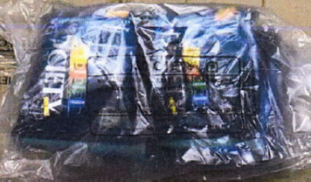
Technical Specifications: - (For 100g Tea Pouch)
Sr No. | Packaging System Describtion |  | QTY
1 | Flow Wrapping Machine |  | 1
 | • Filling System | Automatic
 | • Type of sealing | Centre seal
 | • Packaing Material | Tea
 | • PP Speed | 40/120 pouches per min.approx.
 | • Power | Motor 1.5 HP, DC Drive
 | Collector For Wrapping Machine |  | 1
2 | Printing Provision For Pouches |  | 1
3 | Roller Flattening Conveyor |  | 1
 | • Conveyor Width | 300 mm
 | • Conveyor Length | 1000 mm
 | • Construction | MS Powder Coated
 | • Contact Parts | SS304
 | • Motor | Bonfiglioli with Gear
4 | Check Weigher & Rejector with Conveyor |  | 1
 | • Make | Technofour Electronics
 | • Model | CW1200
 | • Display | Graphic LCD
 | • Maximum weight | 100 g
 | • Weighing Scale | 0-100 g
 | • Accuracy | is + /- 1 gms
 | • Conveyor Belt | Belt Type
 | • Conveyor Belt Width | 300 mm
 | • Speed | 150 pouches/min
 | • Sensor | Load Cell
 | • Material of construction | MS Powder Coated
 | • Rejection Mechanism | Conveyor Stoppage/Pneumatic Pusher Type
 | • Power Consumption | approx. 350 VA
5 | Collating Conveyor |  | 1
 | • Conveyor Length | 1200 mm
 | • Construction | MS Powder Coated
 | • Contact Parts | SS304
 | • Motor | Bonfiglioli with Gear
6 | Automatic Carton Erector Machine |  | 1
 | • Production speed | 12 cartons/min
 | • Carton size(mm) | 478 L x 305 W x 510H
 | • Power supply | 110/220V50/60HZ 1Phase 200W
 | • Air Compressing | 6kg/cm³
 | • Adhesive tape width | 48/60/75MM
 | • Machine dimension | L2000xW1900xH1450mm
 | • Machine weight | 450 Kgs
 | • Motor | Bonfiglioli with Gear
7 | Gravity Cartons/Cylinderical Operation |  | 1
8 | Vibro Flatteners for Cartons |  | 1
 | • Motor | Bonfiglioli with Gear
9 | Automatic Carton Sealer (BOPP Tapping) |  | 1
 | • Carton Size | 478 L x 305 W x 510H
 | • Sealing Capacity | About 1000 Standard Case Per Hour
 | • Adhesive Tape Used | BOPP Self Adhesive Tape
 | • Power Sources | 220 V, 50 Hz, 250w
 | • Max Sealing Dimensions { W X H } | 500mm X 600mm
 | •Min. Sealing Dimension { W X H } | 680+-100 mm
 | • Motor | Bonfiglioli with Gear
10 | Barcode Genarator , Sticking | Domino Make | 1
11 | Check Weigher & Rejector Machine |  | 1
 | • Make | Technofour Electronics
 | • Display | Graphic LCD
 | • Maximum weight | 20 kgs
 | • Weighing Scale | 0-20 kg
 | • Accuracy | is + /-0.2 gms
 | • Conveyor Belt | Roller Type
 | • Conveyor Belt Width | 600 mm
 | • Speed | 0.75 Boxes/min
 | • Sensor | Load Cell
 | • Material of construction | MS Powder Coated
 | • Rejection Mechanism | Conveyor Stoppage/Pneumatic Pusher Type
 | • Power Consumption | approx. 350 VA
12 | Printing Provision On Cartons |  | 1
 | • Brand | Domino
 | • Max line speed (SL 5x5) | 325m/min
 | • IP Rating | IP55
 | • Operating Temp | 5-45 deg c
 | • Power Requirement | 100-240 V, 50-60Hz
 | • Weight | 24.5 kgs
13 | Scanning & Monitoring |  | 1
 | • Brand | Motorola
14 | Palletization for Carton with Scanning RFID & Barcode |  | 1

Images : -
1. Roller Flattening Conveyor 2. Check Weather & Rejecter Machine




3. Automatic Carton Sealer M/c 4. Barcode Generator & Sticking m/c
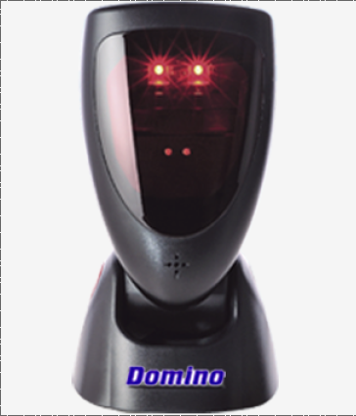

3. Printing Machine 3. Scanners

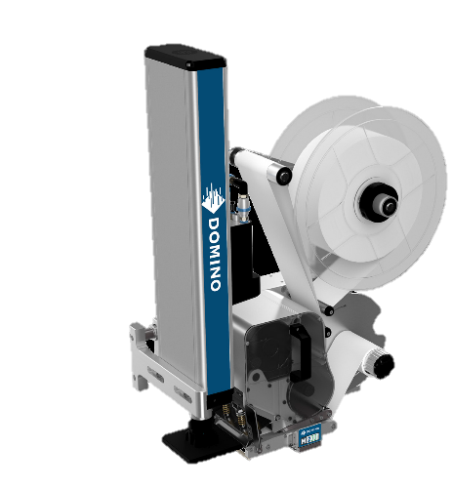
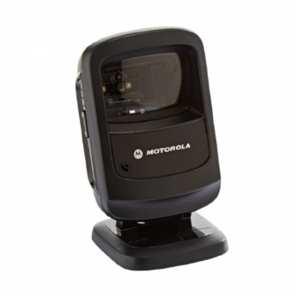

Pricing : -
Sr No. | Description |  |  |  | Qty | Unit | Rate IN INR | Net Amount
1 | Flow Wrapping & Collector Machine |  |  |  | 1 | No | 7,00,000 | 7,00,000
2 | Printing Provision For Pouches |  |  |  | 1 | No | 4,50,000 | 4,50,000
3 | Roller Flattening Machine |  |  |  | 1 | No | 1,50,000 | 1,50,000
4 | Check Weigher & Rejecter Machine |  |  |  | 1 | No
5 | Collating Machine |  |  |  | 1 | No | 3,00,000 | 3,00,000
6 | Carton Erector Machine & Conveyor |  |  |  | 1 | No | 10,00,000 | 10,00,000
7 | Gravity Carton/cylindrical operation |  |  |  | 1 | No | 1,00,000 | 1,00,000
9 | Vibro Flattening |  |  |  | 1 | No | 1,50,000 | 1,50,000
9 | Automatic Carton Sealer Machine |  |  |  | 1 | No | 3,50,000 | 3,50,000
10 | Barcode Reading /sticking/Generation |  |  |  | 1 | No | 9,00,000 | 9,00,000
11 | Check Weigher & Rejecter Machine |  |  |  | 1 | No
12 | Printing Provision For Cartons |  |  |  | 1 | No | 4,50,000 | 4,50,000
13 | Scanning & Monitoring |  |  |  | 1 | No | 2,00,000 | 2,00,000
14 | Palletization |  |  |  | 1 | No | 8,00,000 | 8,00,000
 | Total Amount |  |  |  |  |  |  | 55,50,000
 | Amount In Words |  |  |  |  | Rupees Fifty Five Lacs Fifty Thousand Only

G. Terms and Conditions: -

- Price : Ex. Works Pune

- P & F : 3 % Extra at the time of delivery.

- Freight Notes : Extra as applicable.

- Delivery : Within 9- 10 weeks from date of receipt of
confirmed purchase order, advance payment,
drawing approval.

- Payment Terms : 80% advance along with confirmed purchase
order balance before dispatch.

- Insurance : Extra as applicable.

- GST : Extra as applicable on total supply value.

- Validity : 15 days from date of quotation.

9.Warranty : 12 months from date of supply.

Please feel free to contact Mr. Mayur Derle on 7709209333 for any further clarification in this concern.

With Best Regards,
Pooja Badre
7709209333
For NIHVA Technologies Pvt Ltd

